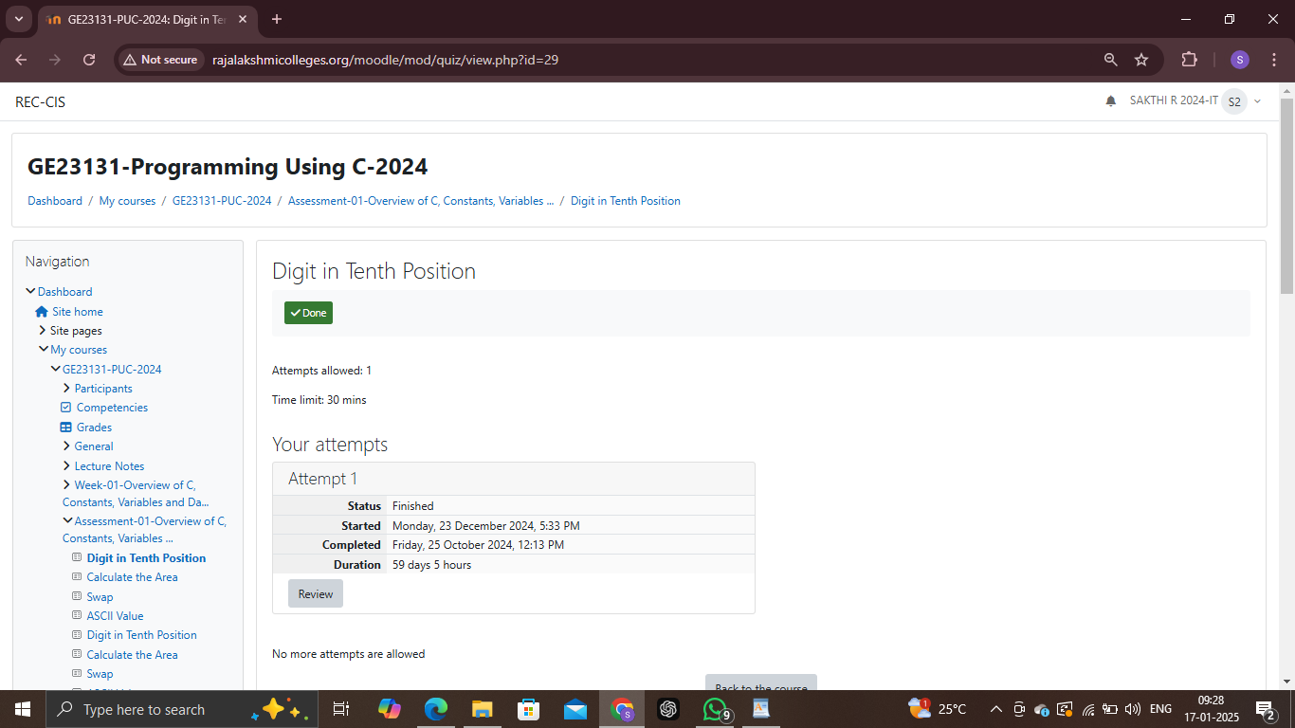

1)The program must accept a positive integer N and print the digit in the tenth position.

Input Format:

The first line denotes the value of N.

Output Format:

The first line contains the value of N.

Boundary Conditions:

10 <= N <= 9999999

Example Input/Output 1:

Input:

20

Output:

2

Example Input/Output 2:

Input:

37843

Output:

4

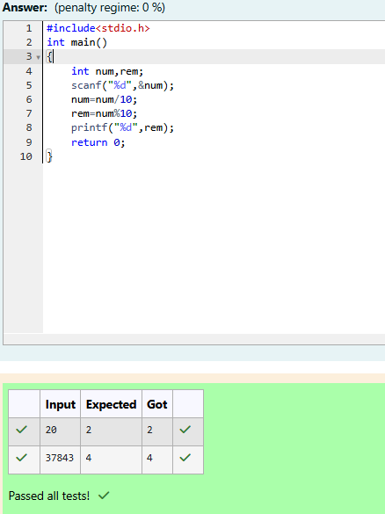

2)Write a C Program to calculates the area (floating point number with two decimal places) of a

Circle given it’s radius (integer value). The value of Pi is 3.14.

Sample Test Cases

Test Case 1

Input

7

Output

Area of a circle = 153.86

Test Case 2

Input

50

Output

Area of a circle = 7850.00

Test Case 3

Input

42

Output

Area of a circle = 5538.96

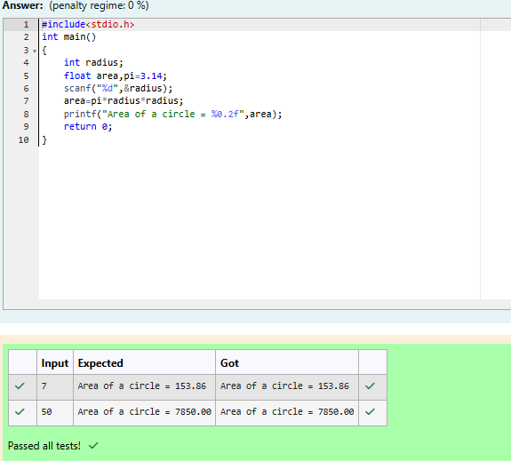

3)Develop a 'C' program to swap two numbers (using three variables).

Input

10 20

Output

Before swapping :

a = 10 b = 20

After swapping :

a = 20 b = 10

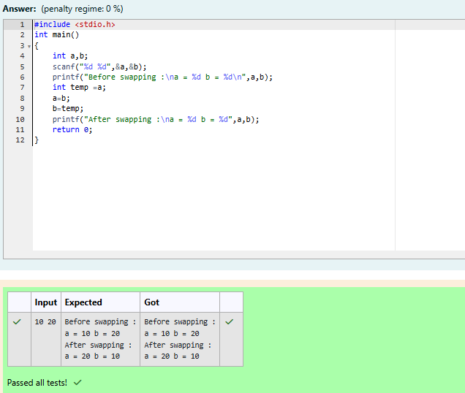

4)

Write a program to print the ASCII value of the given character.

Input

A

Output

The ASCII value of the given character A is : 65

